Holy Nights Gathering 2022-23
“The Dream Song of Olaf Åsteson”
January 5, 7:30 pm

~ offered by the Branch Festivals Group ~
Greater Washington Branch, Anthroposophical Society

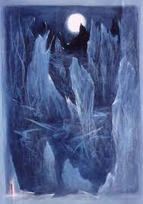
~ The Dream-Song of Olaf Åsteson ~
David Newbatt

“The Dream Song of Olaf Åsteson” is an ancient Norse epic poem which tells of the mystical journey of Olaf Åsteson as he lay sleeping during the Holy Nights. Rudolf Steiner asserts that his journey was actually an initiation leading to a vision of the Christ.

We offer this poem, with an accompanying lecture by Rudolf Steiner, for your contemplation during the Holy Nights.

We invite you to join in a gathering on January 5, 7:30 pm, at the home of the Fosters, to experience a participatory reading of the epic poem, followed by light refreshments and conversation.

To let us know you are coming, and to ask for directions, please email nfoster14thst@gmail.com.

